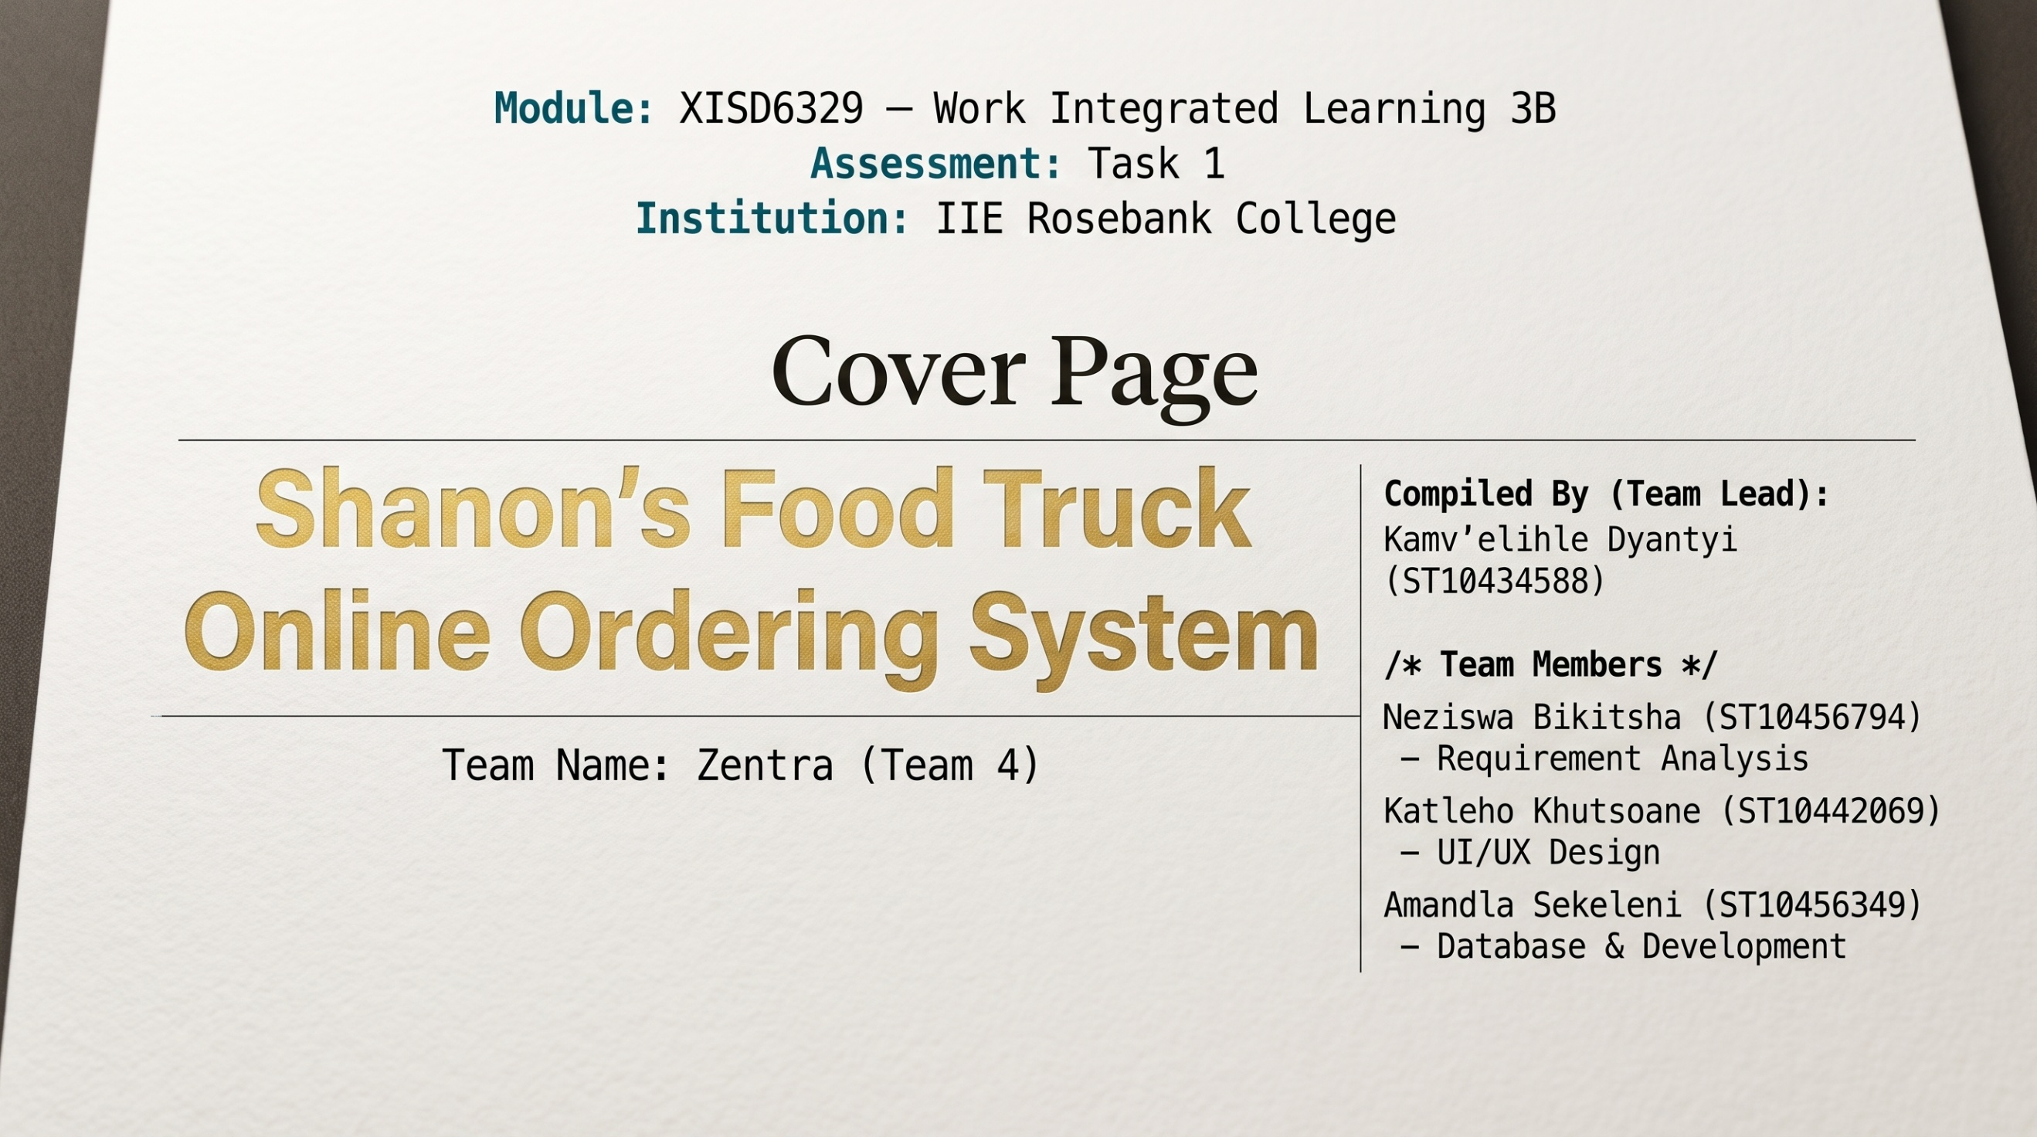
Contents
Introduction 3
Client Needs Description 4
Project Plan & Task Delegation 5
DevOps Lifecycle & Technical Workflow 6
System UI/UX Architecture 7
Github Proof of life 8

Introduction
The development of Shannon’s Food Truck Online Ordering System has been a journey of immense dedication and growth for the Zentra team. What began last year as a theoretical planning and systems analysis exercise has now evolved into a fully fledged software development project. Navigating the initial requirements and breaking down the complex phases of this system demanded significant time and hard work from every member. However, this rigorous process was invaluable, it fundamentally transformed u from a group of students into a cohesive , professional development unit , fully equipped to bring this vision to life.
At the heart of this project is Shannon, a dedicated local entrepreneur operating out of Parklands. Her food truck specializes in hearty, delicious, and highly affordable fast food—most notably her signature Kotas, alongside chip rolls, hot chips, and refreshing beverages. Shannon’s primary customer base consists of people on the go, particularly local construction workers and busy individuals who rely on her for a quick, filling, and satisfying meal during their day.
As her popularity has grown, relying on manual orders and informal communication is no longer sustainable. Our core objective is to bridge this operational gap by developing a robust website and mobile application. This digital ordering system is designed to be highly reliable and incredibly intuitive, ensuring that anyone can easily browse the menu and place an order. Ultimately, this platform will empower Shannon to streamline her daily operations, expand her business reach, and ensure her wonderful food can be enjoyed by a much wider audience.

Client Needs Description
Problem 1: Sales Channel Fragmentation ("The WhatsApp Chaos")
- Current State: Sales occur via walk-ups and WhatsApp orders. WhatsApp threads are difficult to track, leading to:
  - Missed or duplicate orders.
  - Lost customer communication.
  - Inability to forecast demand.
- Client Need: A unified digital ordering platform that consolidates all orders into a single dashboard, eliminating manual tracking.
- System Solution: Both website and mobile app will feed orders into a central database accessible via an Admin Dashboard.
2.2 Problem 2: Inefficient Inventory Management ("The Big Payoff")
- Current State: Shanon buys stock based on "guesswork" rather than actual demand, resulting in:
  - Over-purchasing leading to food waste.
  - Under-purchasing leading to stockouts and lost sales.
  - Financial losses due to spoilage of ingredients requiring specific storage conditions.
- Client Need: A system that predicts required stock based on orders placed, providing daily/weekly purchase recommendations.
- System Solution: The system will track ingredient usage per order and generate a Daily Purchase Recommendation Report showing exactly how much of each ingredient to buy.
2.3 Problem 3: Lack of Brand Presence ("Stepping Up Advertising")
- Current State: No digital footprint beyond word-of-mouth.
- Client Need: A professional website to attract new customers, showcase the menu, and build brand credibility.
- System Solution: A responsive, visually appealing website with an integrated ordering system.

3. Stakeholder Identification
Stakeholder | Role | Needs/Expectations
Shannon (Owner) | Primary Client | - Reduce operational chaos  - Minimize food waste  - Increase sales through online exposure  - Easy-to-use admin dashboard
Customers | End Users | - Quick and easy ordering via web or mobile  - Clear menu with prices  - Order confirmation and pickup time
Food Truck Staff | Operational Users | - Receive orders in real-time  - View prep lists  - Simple interface (low tech literacy)
Development Team | System Builders | - Clear requirements  - Access to client feedback  - Adequate time for testing
Lecturer / Evaluator | Project Assessor | - Adherence to assignment brief  - Quality of documentation and code

4. Functional Requirements
Functional requirements describe what the system must do to meet Shannon’s needs.

4.1 Customer-Facing Functions (Website + Mobile App)
ID | Requirement | Priority | Platform
FR-01 | Users must be able to browse the menu with item names, descriptions, prices, and images. | High | Web + Mobile
FR-02 | Users must be able to filter menu items by category (e.g., Breakfast, Lunch, Beverages). | Medium | Web + Mobile
FR-03 | Users must be able to add items to a cart and adjust quantities. | High | Web + Mobile
FR-04 | Users must be able to place an order by providing name, phone number, and preferred pickup time. | High | Web + Mobile
FR-05 | Users must receive an order confirmation with order number and estimated pickup time. | High | Web + Mobile
FR-06 | Users must be able to view order history (mobile app only for Phase 1). | Low | Mobile
FR-07 | Users must be able to register/login for faster future orders (optional). | Medium | Web + Mobile

4.2 Admin-Facing Functions (Dashboard for Shanon)
ID | Requirement | Priority | Platform
FR-08 | Shannon must be able to view all incoming orders in real-time on a single dashboard. | High | Web
FR-09 | Shannon must be able to mark orders as "Preparing," "Ready," or "Completed." | High | Web
FR-10 | The system must automatically generate a Daily Purchase Recommendation listing ingredients required based on orders received. | High | Web
FR-11 | Shannon must be able to update the menu (add/edit/remove items, change prices). | Medium | Web
FR-12 | Shannon must be able to view sales analytics (daily/weekly revenue, top-selling items). | Medium | Web

4.3 System Functions (Backend)
ID | Requirement | Priority
FR-13 | The system must store order data in a database for retrieval and analysis. | High
FR-14 | The system must calculate ingredient consumption based on menu recipes. | High
FR-15 | The system must send push notifications to mobile users for order updates. | Medium
FR-16 | The system must support secure payment integration (optional Phase 2). | Low (Phase 2)

5. Non-Functional Requirements
Non-functional requirements describe how well the system performs its functions.
ID | Requirement | Category
NFR-01 | Usability: The website and app must be intuitive for users with minimal tech literacy. | Usability
NFR-02 | Mobile Responsiveness: The website must work seamlessly on smartphones, tablets, and desktops. | Performance
NFR-03 | Performance: Pages must load within 3 seconds on standard internet connections. | Performance
NFR-04 | Availability: The system must have 99.5% uptime during operating hours (6 AM – 8 PM). | Reliability
NFR-05 | Security: All user data and orders must be transmitted via HTTPS. | Security
NFR-06 | Scalability: The system must handle at least 500 orders per day with no degradation. | Scalability
NFR-07 | Maintainability: Code must be well-documented for future enhancements. | Maintainability
NFR-08 | Offline Mode (Mobile): The mobile app should allow menu browsing offline (cached data). | Usability

6. User Stories (Use Cases)
To make requirements clearer, here are user stories from the perspective of different users:
As a customer...
- "I want to view the menu on my phone so I can decide what to order before I arrive."
- "I want to place an order and choose a pickup time, so my food is ready when I get there."
- "I want to receive a confirmation, so I know my order was received."
As Shannon (Owner)...
- "I want to see all orders in one place, so I don't miss any WhatsApp messages."
- "I want to know exactly what ingredients to buy each day, so I don't waste food or money."
- "I want to easily update my menu when I run out of an item."
As Food Truck Staff...
- "I want to see a clear list of orders with prep instructions so I can cook efficiently."
- "I want a simple interface that doesn't require complex training."

7. Constraints and Assumptions
7.1 Constraints
- Budget: Limited to free/open-source tools (No paid third-party services in Phase 1).
- Timeline: 10 weeks for full development (planning, coding, testing, deployment).
- Tech Stack: Must align with assignment requirements (HTML/CSS/JS for website, React Native/Flutter for mobile).
- Team Size: 3 members maximum.
- Hosting: Must use free hosting services (e.g., Netlify, Vercel, Firebase).
7.2 Assumptions
- Shanon has basic internet access and a smartphone/computer.
- Shanon can provide ingredient recipes (e.g., "Burger uses 200g beef, 1 bun, etc.") for inventory calculation.
- Customers have access to smartphones or computers with internet.
- Payment gateway integration is out of scope for this phase (orders will be "cash on pickup").
- The system will only support English in Phase 1.

Project Plan & Task Delegation
Team member | Last Semester | This Semester
Kamv’elihle | Project Lead/WBS: Responsible for defining task sequences, estimating durations , and mapping milestones. | Team Lead: Overseeing GitHub repository structure , writing DevOps notes, and managing strict deadlines
Katleho(Kat) | Software Developer: Tasked with the initial website and ordering system design. | UI/UX & Design: Fully specialized into creating sitemaps, wireframes, and compiling the final document formatting.
Neziswa(Nez) | Software Developer: focused heavily on economic feasibility study. | Requirement Analysis: Dedicated strictly to defining and detailing the Client's Needs section.
Amandla(Ama) | Risk manager: Responsible for compiling the risk register and detailing proactive management steps | ERD/DB & Frontend: Pivoted entirely from theoretical risk planning to hands-on coding of the HTML pages based on Kat's wireframes.

DevOps Lifecycle & Technical Workflow
4.1 Continuous Planning- Project management and task delegation are tracked using AZURE DevOps Boards. The development cycle is divided into interdependent sprints , with tasks strictly aligned to the systems structural modules: the Customer Portal (Menu, Cart, Checkout, Order Status) and the Admin Dashboard (Login, Menu Management, Inventory).

4.2 Version Control & Branching Strategy-All source code and documentation are hosted in a centralized GitHub repository (KamvelihleAthabileDyantyi17/Zentra). To protect the integrity of the live application, direct commits to the main branch are restricted. Developers must utilise a feature-branching strategy, creating specific branches for designated UI components (e.g., feature/customer-checkout or feature/admin-inventory).

4.3 Continuous Integration (CI) & Code Review-Because the system’s architecture requires tight integration between the UI design and backend logic, code is strictly gated by a Pull Request (PR) workflow. Before any code is merged, the Team Lead executes a mandatory code review to ensure the HTML views match the approved wireframes and site map layout. Additionally, to avoid hardware bottlenecks caused by Android Virtual Devices, performance testing and debugging are executed directly on physical Android smartphones.

4.4 Continuous Deployment (CD)- Upon a successful PR merge into the main branch, the deployment pipeline synchronizes the updated code. The presentation layer updates are pushed to the live web hosting environment, while backend SQL queries automatically map to our connected cloud database architecture.

System UI/UX Architecture
5.1 Application Site Map
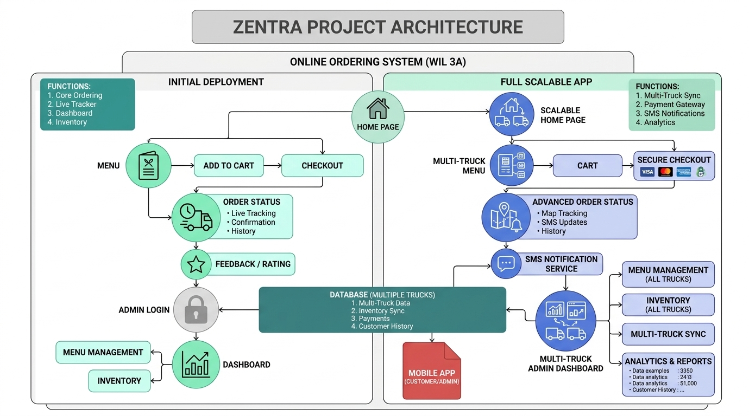
5.2 Interface Wireframes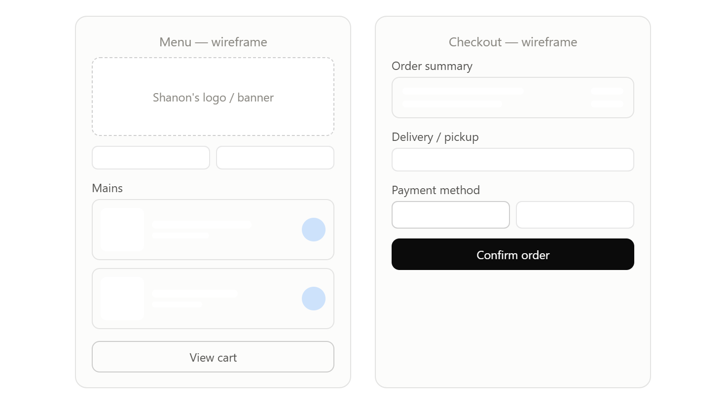

Github Proof of life
Repo link: https://github.com/KamvelihleAthabileDyantyi17/Zentra.git

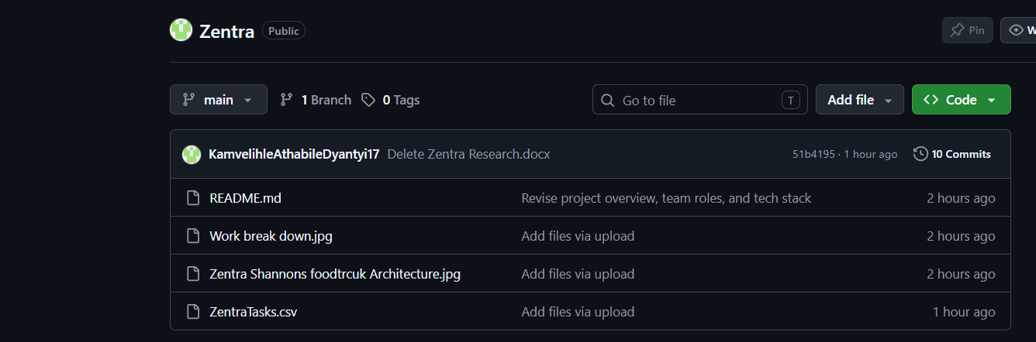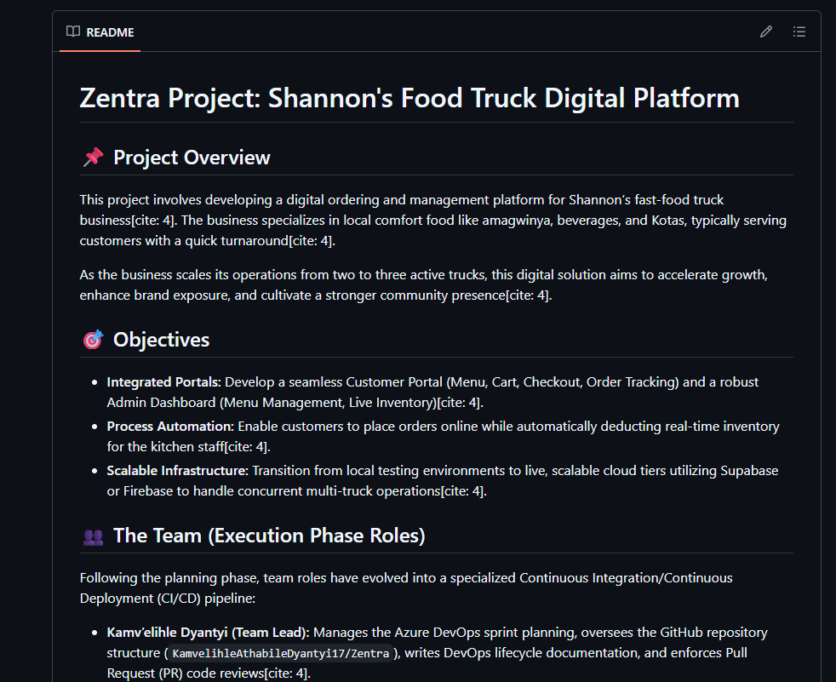

Azure DevOps
Work Items

